Font Information:

Level 1 Font: **Stalker1**: Downloaded From: <http://www.dafont.com/stalker2.font>

Level 2 – 3 – Normal Font: : Downloaded from: <http://www.fontsquirrel.com/fonts/gandhi-sans> **Gandhi-Sans Bold**

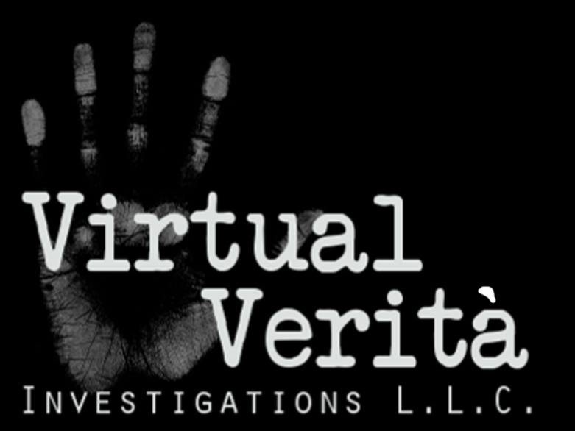

I would like the top menu to read:

Criminal / Civil Cases - [Cyber Attack](http://play.bekkit.com/pages/cyber_attack.html)s - [It's Complicated](http://play.bekkit.com/pages/its_complicated.html) -[Business Investigation](http://play.bekkit.com/pages/business_investigations.html) - [Check My Spouse](http://play.bekkit.com/pages/check_my_spouse.html) - [Child Protection](http://play.bekkit.com/pages/child_protection.html)- [Cyber Harassment](http://play.bekkit.com/pages/cyber_harassment.html)-

* I think Criminal / Civil Cases is better than “Legal Forensics”

“I’m focusing on Lawyer conferences this spring and will be meeting about 750 of them!”

* Put About Us at the bottom
* Put a new link at the bottom:  “Information Security Services” and put the content from “Risk Management” on that page.
* Put a “Home” link on the top banner.
* No links for Business Services / HIPAA or Risk Management
* I’m thinking only use 7 pictures for the home page slide show.

# About Us

## Virtual Verità Investigations is unique and we offer digital forensics services to the public.

**Virtual Verità Investigations L.L.C. is a licensed and insured professional investigation agency. We are scientists, technologists, educators, consultants, and people just like you.**

**The science of digital forensics has traditionally focused on law enforcement, legal professionals and business. Today, computer and Internet technology continues to grow beyond the public’s ability to manage the risks and threats that technology represents.**



**We are not the same as some digital forensics practitioners and we offer different types of services and programs never offered before to our knowledge.**

* **Serving the Public: We offer a wide variety of affordable digital forensic services and investigations for the public**
* **Remote Investigations: In certain cases we can speed up investigation times to near real time and reduce costs**
* **Quid Pro Quo Program: Our services at a reduced cost for your story. We support the science and profession of digital forensics and information security using your story. You get a price break.**

## We provide services to help the community, legal professionals, business, and government determine the Virtual Verità (Truth) and JUSTICE in the digital jungle.

**Virtual Verità Investigations L.L.C. has a secure digital forensics lab with powerful computers and specialized software programs used to extract digital fingerprints to establish timelines, locations, activities, identity, authenticity, and much more. The investigators at Virtual Verità have years of education, training, and several years of experience.**

**The primary investigator and founder is Jeff Cleveland**

**[My Picture ]**



**15+ years IT Security experience as an IT consultant, professor, and IT program chair.**

**Master’s Degree in Information Management**

**Graduate Certificate in Information Assurance**

**PhD: Current – Computer and Information Security**

**Licensed Professional Investigator**

**Several technical and security certifications including:**

* **Certified Computer Forensic Examiner (CCFE)**
* **Certified Information Systems Security Professional (CISSP)**
* **Certified Forensic Consultant (CFC)**
* **CompTIA Certified Security+**

Get a free confidential no obligation quote now!

**Civil / Criminal Law**

**Digital content is more relevant now than ever before in history. Cases are being won or lost based on a simple email, a deleted file, or a text message. Other cases involve encrypted files, Terabytes in the cloud, Smart Phones and the data centers with extreme complexity.**



**Yes digital evidence is growing in volume and value in both civil and criminal cases. Many Attorneys / Businesses will use “IT Guys” or the “do-it-yourself (DIY)” approach instead of Virtual Verità Investigations Digital Forensics experts.**

**As a result, digital evidence will be insufficient or unacceptable in court due to:**

**• Unacceptable evidence collection methods**

**• Poor documentation**

**• Spoliation or tampering**

**• Overlooked evidence**

**• Lack of knowledge, tools, and reporting**

**• Inability to testify with understanding before a jury**

**• Inherent evidence bias and failure to engage an objective third party**

**Virtual Verità Investigations can help you avoid these problems.**

**\* We use court accepted scientific methods and procedures**

**\* Correct and court acceptable documentation and reports to protect evidence integrity**

**\* Acceptable and thorough evidence collection and analysis**

**\* Unbiased evidence and facts presented in an unbiased and easy to understand manor**

Anyone who uses a computer or smart phone to communicate leaves digital tracks.

* 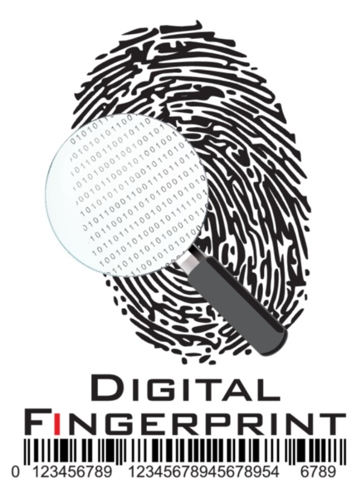**Add power to your case and speed up the settlement time.**
* **Support or discredit witness testimony**
* **Establish or refute facts and intentions**
* **Establish or refute place and time**
* **Determine digital evidence authenticity**
* **Gain perspective on digital evidence and points for argument**
* **Have a professional investigator gather and preserve digital evidence civil lawsuits.**

**If you want digital evidence that fulfills the legal requirements for authenticity, reliability, and**

**Integrity, request a free quote now!**

# Quid Pro Quo Program

**Quid Pro Quo means “this in exchange for that.” You may receive professional services at a discount.**

## If you have an interesting investigation or story, or you’re out of money but you have a worthy cause, then you should consider participating in the Quid Pro Quo Program.



**(*The Quid Pro Quo program offers discounted investigations, reports, and potentially depositions, and expert testimony in exchange for media rights to your story and an anonymous customer review. Virtual Verità intends to keep your identity confidential and anonymous to protect client privacy to the greatest extent possible.)**

***Submit a confidential no obligation request for a quote and select “Participate in Quid Pro Quo program “or CALL (810) 771-5353 and request to participate.***

**(* Request for participation in the Quid Pro Quo Program does not guarantee acceptance or selection for participation. This offer may end without notice and only a limited number of cases will be accepted into the Quid Pro Quo Program. Media release and project contracts must be signed prior to work start)**

# It’s Complicated



**When it comes to technology created problems, or problems created using technology, nothing is simple. Between online dating, social networking, and smart phone video sexting there’s plenty of strange things that can happen.**

## Virtual Verità Investigations is ready to help you simplify your complicated situation.

**Just when you thought life couldn’t get any stranger, someone decides to prove you wrong. Now there is someone who can help you figure out the complex problems that arise from today’s technological paradox.**



## Fear Not! There are a lot of things that can be done:

* **Finding your lost Internet date, your daughter’s internet date, or…??.**
* **Getting text messages from strangers?**
* **Facebook friends seem to know a lot about you but you don’t know anything about them?**
* **What about email from someone who knows you but you don’t know them?**
* **Would you like to physically locate someone who is online? networks**
* **Perhaps you would like to identify anonymous perverts online?**
* **Are you considering capturing evidence for the authorities or a lawsuit in civil court?**
* **Maybe your smart phone or computer has been hacked**
* **Who posted comments on your business page or blog?**

### If your complicated problem is not on the list, don’t let that stop you from calling and getting a free confidential no obligation quote now!

Spouse Investigations

**There are many different reasons why digital forensics can be very helpful in spousal investigations. You should know that the state of Michigan is a no-fault divorce state and infidelity does not have to be proven. However, you might consider digital forensics for several other reasons besides infidelity.**



**We can examine and extract evidence from computers and smart phones to help you:**

* **Determine if your spouse has accessed your email or other files.**
* **Determine if your spouse has bugged your computer or smart phone.**
* **Assess the possibility of the infidelity and cyber-sexual activity.**
* **Gather evidence of abuse, neglect, harassment, theft, or unlawful activity to be provided to police from your smart phone or shared computer.**
* **Review Internet use and search activity including the applications used.**
* **Locate a missing spouse using digital evidence from a shared computer or smart phone.**



***Get a free confidential no obligation quote now!***

# Child Protection Investigations

**Do you suspect that something is wrong in your child’s life? Perhaps you already dismissed whatever it is to just growing pains. Well protecting children and giving them good advice is what good parents do. The problem is that young people can hide their depression, troubles, or anxiety from parents or shut parents out so they can’t help. We may be able to provide you the information you need to talk to your child, find your child, or prosecute an offender if necessary.**

## We are here to help you and your young person when you need it.

### 

### Does your child have a problem with Cyberbullying or Sexting?

**According to Bullying Statistics: [link to** [**http://www.bullyingstatistics.org/content/cyber-bullying-statistics.html**](http://www.bullyingstatistics.org/content/cyber-bullying-statistics.html) **]**

* **Over 50% of young people have been or engaged in cyberbullying others at some time.**
* **The majority of young people being bullied are not likely to tell their parents**
* **33% of adolescents have experience online threats**
* **20% of minors have sent or received sexually suggestive or nude selfies**
* **10% of minors have had embarrassing or damaging photos taken without permissions circulated online**
* **80% of adolescents use smart phones; the most common device used for bullying**

### 

### Did your child run away, leave suddenly, or was taken by a relative or spouse?

**We may be able to help you locate your child, and you have a good reason to be concerned. Many runaways end up on the streets and are exploited and abused by sex traffickers.**

**According to the 2013 Annual Report of the National Center for Missing and Exploited Children NCMEC [link to:** [**http://www.missingkids.com/AnnualReport**](http://www.missingkids.com/AnnualReport) **]**

* **10,094 children were reported missing in 2013**
* **14.3% of endangered runaway children reported were identified as likely victims of child sex trafficking**

***Don’t wait to help your child and get a free confidential no obligation quote now!***

# Cyber Stalking - Harassment

**Cyber-stalking or harassment can happen to anyone and there are several things you can do including report it to the police and possibly a lawsuit. If you don’t know who is stalking or harassing you, we can help you find out confidentially. Perhaps you are afraid to report it? Why not let us help?**

## 

## We can gather evidence in a court acceptable manner, create professional reports, and testify in court if necessary.

**Cyber stalking and harassment causes a person to fear for their safety and may include such things as:**

* **Distribution of personal sexual photographs or embarrassing photographs**
* **Threatening violence or harm in insulting emails or text messages**
* **Unwanted sexually explicit material in email, mail, or text messages**
* **Making unreasonable or offensive demands, or ultimatums in email or text**
* **Making statements that would cause a reasonable person to fear for their safety**
* **Making discriminatory or derogatory remarks about sexual preference, race, sex, or religion**



## ***Call now for a free confidential no obligation quote!***

# Cyber Attack Investigation

**Computer systems are attacked continuously. It doesn’t matter if you are an individual, small business, medium business, large business, or government agency; you are constantly under attack if you are connected to the Internet. The new malware used to steal from Target and Sony cannot be detected by anti-virus.**

## Your systems may have been compromised for years without you even knowing it!

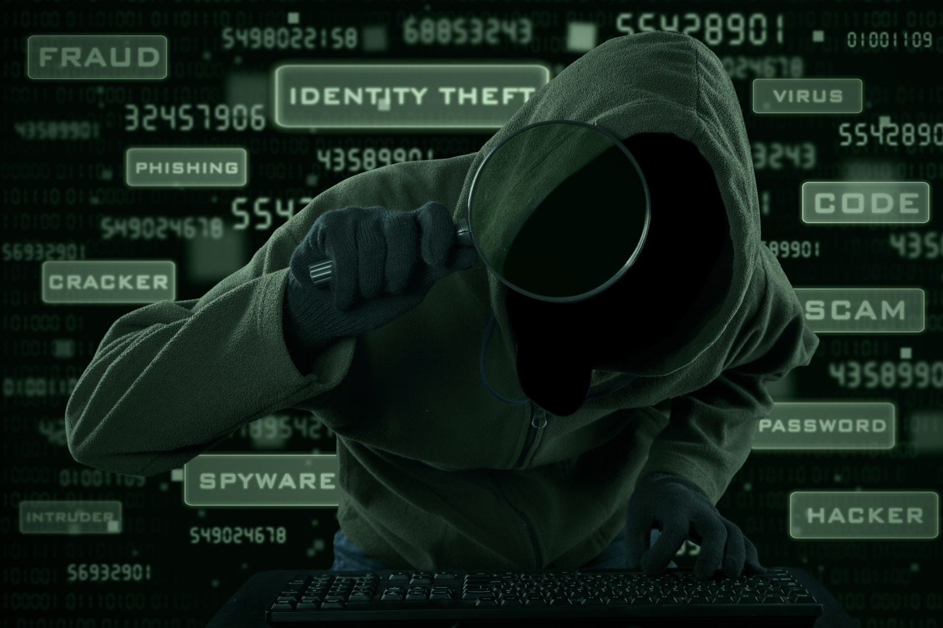

**Why would anyone attack your system(s)? It doesn’t matter if you are an individual, small business, or large organization criminal hackers are interested in:**

* **Stealing your identity, your families, and / or your employees identity**
* **Infecting your systems using phishing emails and stealing your contacts**
* **Stealing credit card and credit account information**
* **Stealing money from your credit cards or financial accounts**
* **Controlling your computer(s) without your knowledge to attack other systems or store malware**

**Malicious hackers may be living with you, working for you, or neighbors who don’t mind their own business. Chances are they left a digital fingerprint behind. We don’t promise we can catch the thief, but if you don’t investigate then you will never know.**

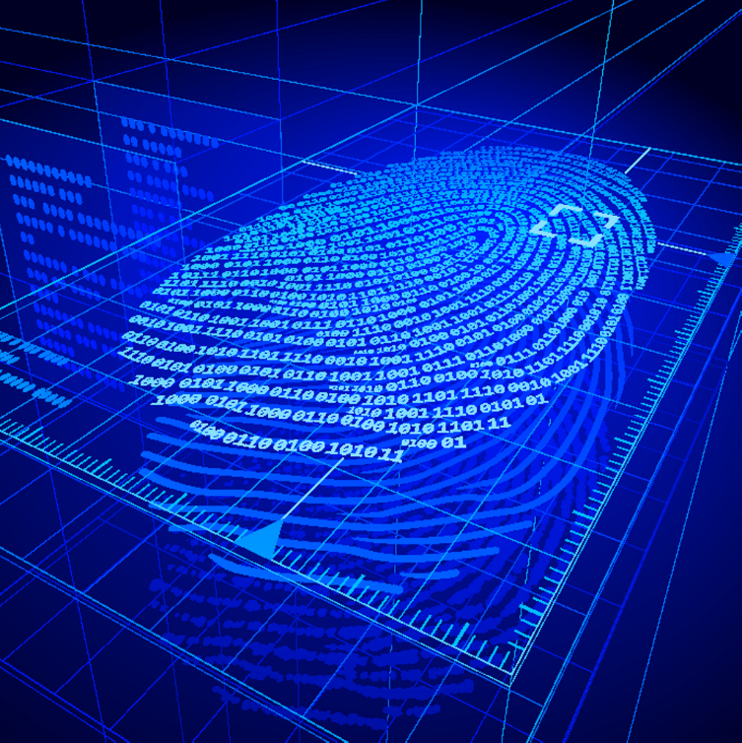

***If you suspect your systems have been hacked or infected call Virtual Verità Investigations now for a free confidential no obligation quote***

# Business Investigations

**Virtual Verità can help your business by investigating employee conduct and activity. Virtual Verità can gather evidence and investigate in a confidential, unobtrusive, and court acceptable fashion. Call us when it’s time to do something.**

## Why take a chance on the IT guy who may be part of the problem? Some things just aren’t funny.



**In fact there are many different possible scenarios where internal employees must be investigated to determine if any civil or criminal liability may exist:**

* **Investigate claims of employee harassment or discrimination**
* **White collar crime such as embezzlement and accounting fraud**
* **Fraudulent account transfers**
* **Employee system misuse for pornography, social networking, storage of copyrighted material on your servers**
* **Regulatory compliance violations for Sarbanes-Oxley, HIPAA – HITECH, GLBA, PCI-DSS, Federal Trade Commission and Bureau of Consumer Protection.**
* **System administrator abuse manipulating systems for spying, snooping, or personal gain**
* **Internal data theft of copyrighted intellectual property, customer lists, personally identifiable information, patents, trade secrets, software and more..**



***Don’t let just anyone gather the evidence.***

***Call Virtual Verità Investigations now for a free confidential no obligation quote***

# Consulting Services

**Virtual Verità offers consulting services for a wide variety of information technology security issues. If what you are looking for is not in the sample list of services below that does not mean we cannot assist.**

## Please call to discuss your needs.

## Legal / Litigation support

* **Determine points of argument based on case evidence**
* **Organize and locate digital evidence artifacts**
* **Test existing digital evidence artifacts**
* **Determine hypothetical and potential evidence**
* **Interpret technical details and research evidence**
* **e-Discovery extraction and evaluation support**
* **Depositions and expert witness testimony**

## 

## Security Management Support

* **Project management: We set up a scope, task list, resources, and timeline with you for your security technology project, implement the project, and report progress weekly**
* **Security strategy planning: We work with you to determine your security strategy and develop policy to protect your information assets**
* **Business continuity and disaster recovery: We help you create policy and procedure to manage business interruptions, security incidents, and disaster management**
* **Security assessment / audit: We measure your current security policy against existing systems security to discover strengths and weaknesses in your security policy**
* **Risk assessment / risk management: We analyze your information assets and determine the security threats, impacts, and security controls in place. Then we help you establish a risk management policy and procedures to satisfy your risk tolerance.**
* **Security awareness training: We can help set up a program for security awareness training or conduct training based on your organizational needs**

## C:\Users\Samson\AppData\Local\Microsoft\Windows\Temporary Internet Files\Content.Outlook\911LV8PK\Security-of-Business-People.jpg

## Information Security Engineering

* **Security controls implementation and testing: Firewalls, Proxy Servers, and Content Filters, Remote Access, Encryption Solutions, Authentication, and more..**
* **Penetration testing / vulnerability assessment: Security testing and assessments to suite your needs**
* **Security event monitoring and incident response: Local or remote monitoring of security events and local or remote response investigations**

**Technical research: Virtual Verità can help you answer your technical questions and formulate solutions.**

***Call Virtual Verità Investigations now for a free confidential no obligation quote***

# Free Confidential No Obligation Quotes

F**ree confidential no obligation quotes are offered on a first come first serve basis.**

## All quotes are completed in 4 phases and it may take between one and five business days to complete the quote process.

**Phase I: Speak with a consultant who will gather the facts and details of your project.**

**Phase II: The consultant will research [FREE] project options and fees based on phase I.**

**Phase III: Possible project options and fees are presented [FREE] based on phase II.**

**Phase IV: Finalize quote in contract, initial fees, and project strategy for sign-off and start.**

## CALL: 810 771-5353 or use the secure contact form below



**-------------------------------------------------------------**

**[BEGIN FORM]**

**Submit a Request for Quote:**

**Full Name: [required]**

**Phone: [required]**

**Best time to call:**

**Day  Afternoon Night**

**Email me and I’ll arrange a time to call**

**Email: [required]**

**Participate in Quid Pro Quo Program [LINK TO PROGRAM]**

**Type of Service(s) Requested**

**[one required]**

**Criminal /Civil Cases**

**Cyber Attack Investigation**

**It’s Complicated**

**Business Investigations**

**Check My Spouse**

**Child Protection**

**Cyber Harassment**

**Consulting Services**

**Something Else**

**Details of the request: (Be as specific as you can in 300 words or less. You will be contacted by phone regarding the details. [not required]**

**Just call me for the case details. [not required]**

**[ SUBMIT BUTTON ]**